**ASSIGNMENT - 19.3**

**Problem Statement:**

Task 8: Write a MapReduce program that takes the output of Task 5 (refer session 7, assignment 1) as input, and produce output which is sorted on the total units sold. You may use a single reducer for the sorting. Use Sequence File formats as output of Task 5 and as input for this task.

**Input:**

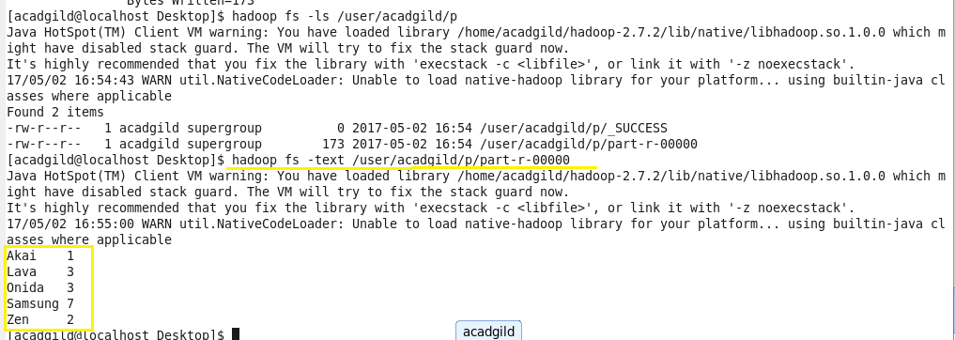

**Program:**

**Driver Class:**

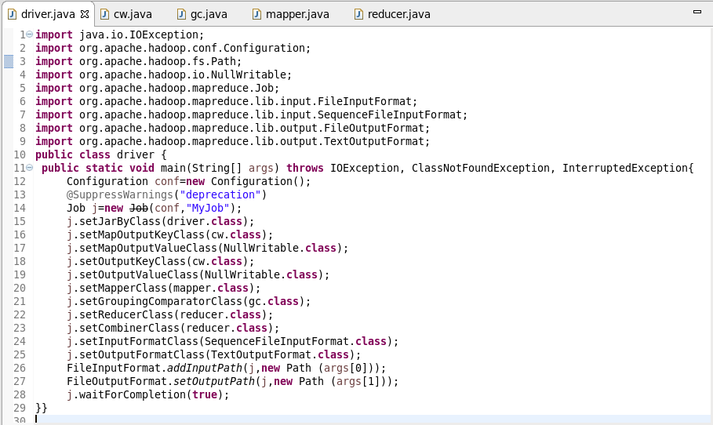

**CustomWritable Class:**

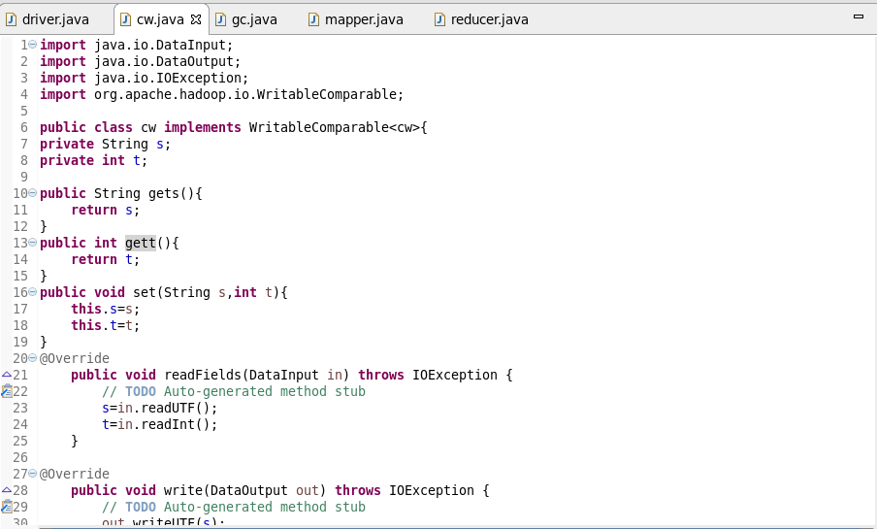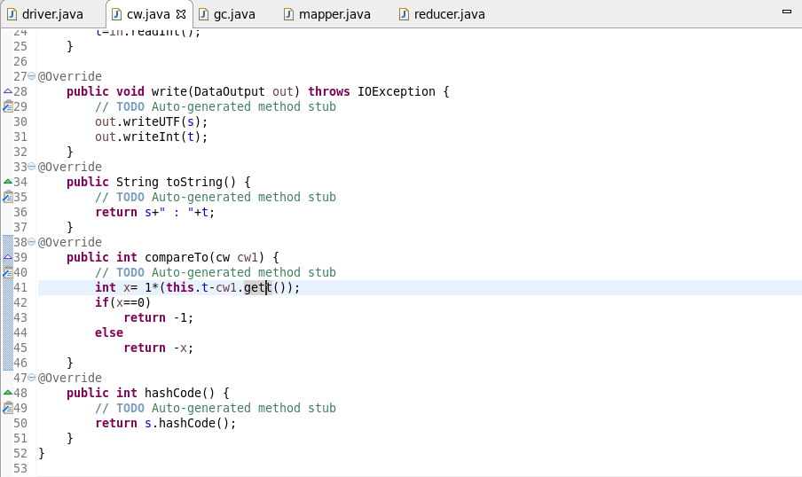

**GC Class:**

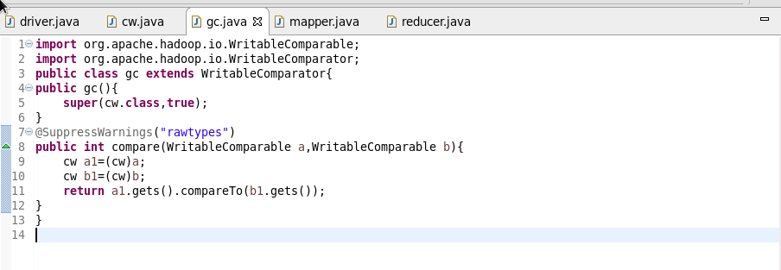

**Mapper Class:**

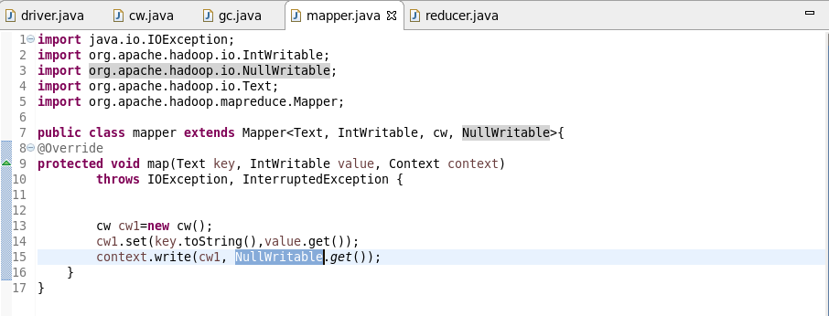

**Reducer Class:**

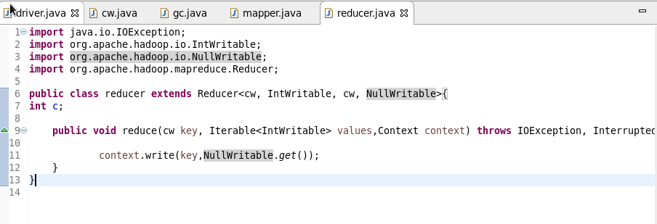

**Output:**

